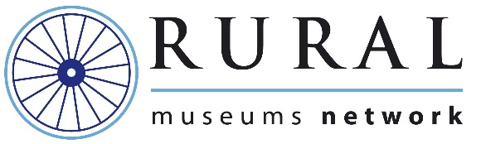

Rural Museums Network Development Study

The Rural Museums Network (a UK-wide Subject Specialist Network) wishes to appoint a person to undertake a primarily desk-based review of the organisation’s current activities and to make recommendations for its future development. It is anticipated that the work will take around 25 days to complete, to a timetable to be agreed.

Expressions of Interest are now invited from suitably-experienced consultants and others who would like to be considered for this appointment. If the person selected for this work is not established in self-employment, a fixed-term appointment may be made to the staff of a host museum. To express interest, please send your CV along with a brief summary outlining your relevant experience, and a note of the daily fee rate or payment you would seek, to Dr Robin Hanley, Chairman, Rural Museums Network, at robin.hanley@norfolk.gov.uk.

Applicants who are then selected to proceed to the next stage will be sent a detailed brief and invited to submit a full proposal.

The deadline for submission of Expressions of Interest is 5pm on Monday 7th March 2016.

If you require any further information please email robin.hanley@norfolk.gov.uk.

